Web-Based ML Model Evaluator
Member 3 Deliverable: SAD Part A (Architecture), Sections 3.3 to 3.9
Field | Value
Project | Web-Based ML Model Evaluator
Repository | SE_498_515_534_911
Version / Status | 0.1 / Draft for team review
Author | Member 3
Merges into | SAD sections 3.3 to 3.9 (Member 4 owns the cover, 1, 2, 3.1, 3.2, 4.x and 5)

Software Architecture Document (SAD): Sections 3.3 to 3.9

3.3 Component (UML) Diagram
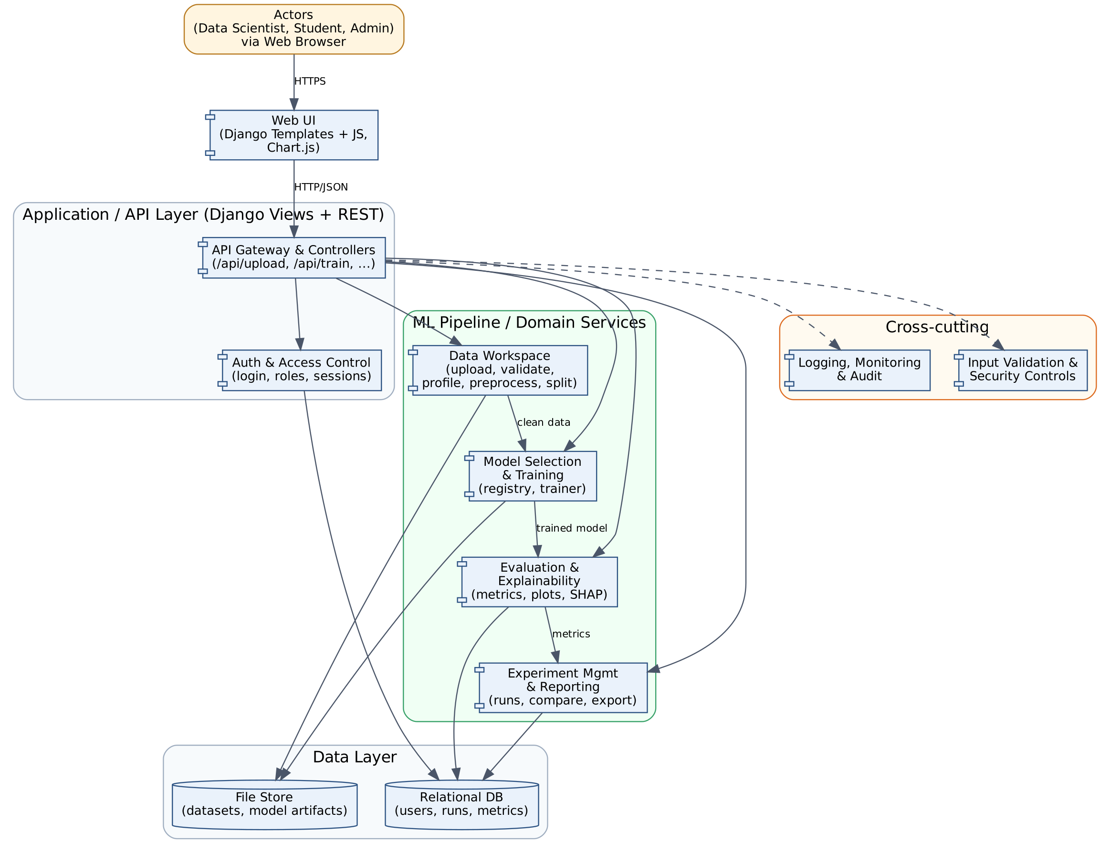
Figure 1: Component diagram. Solid arrows are runtime dependencies; dashed arrows are cross-cutting concerns applied by the API layer.

3.4 Component Descriptions
Component | Responsibility | Maps to Jira epic
Web UI | Renders pages for upload, model selection, training status, results and history. Charts (confusion matrix, metric bars) use Chart.js. Contains no business logic. | WBMME-4 to WBMME-7 (UI parts)
API Gateway & Controllers | Single entry point for all requests (/api/upload, /api/train, /api/evaluate, /api/runs). Validates input, checks authorisation, delegates to services, returns JSON. | All
Auth & Access Control | Registration, login, session handling and role-based access (Data Scientist, Student, Admin). Ensures users only see their own datasets and runs. | WBMME-11
Data Workspace | Accepts CSV upload, validates type, size and schema, profiles the data, handles missing values and categorical encoding, and creates the train/test split. | WBMME-4
Model Selection & Training | Holds a registry of supported scikit-learn models and their hyperparameters. Trains the selected model(s) on the prepared data and stores the trained artifact. | WBMME-5
Evaluation & Explainability | Computes accuracy, precision, recall, F1, ROC-AUC and the confusion matrix. Lists feature importance for models that provide it (Logistic Regression, Decision Tree, Random Forest). | WBMME-6
Experiment Management & Reporting | Records every run (dataset, model, parameters, metrics), supports side-by-side comparison, and exports a run or comparison as a CSV file. | WBMME-7
Logging, Monitoring & Audit | Structured logs of requests, training jobs, failures and admin actions. Never logs raw data values or credentials. | WBMME-11 (and WBMME-9 for deployment logs)
Input Validation & Security Controls | Central file validation, request-size limits, rate limiting, CSRF protection and safe model serialisation. | WBMME-11
Relational DB | Stores users, roles, dataset metadata, runs and metrics. | WBMME-4 to WBMME-7
File Store | Stores uploaded datasets and trained model artifacts in per-user directories outside the web root. | WBMME-4, WBMME-5

3.5 Chosen Architecture Pattern and Rationale
Chosen pattern: Layered architecture (Presentation, Application/API, ML Pipeline/Domain, Data) with the Django MVT structure inside the web tier and a pipe-and-filter style ML pipeline (Upload, Preprocess, Train, Evaluate, Record).
Rationale:
- Separation of concerns: UI changes do not affect ML code, and a model can be swapped without touching the views.
- Matches the workflow. The ML flow is naturally sequential, so each stage is a replaceable component with a defined input and output.
- Fits the team: four students and a two-sprint schedule. A single deployable unit keeps CI/CD, debugging and the demo simple.
- Testable: each layer can be unit-tested with stubs, which supports the Test Plan's unit, integration and system levels.
Alternatives considered and rejected:
Alternative | Reason rejected
Microservices | Needs service discovery, inter-service auth and multiple deployments. Too much overhead for the team size and the sprint length.
Single-file monolith (no layers) | Fastest to start, but couples UI and ML code and makes parallel work on four branches cause merge conflicts.
Client-side ML (in-browser) | Limits model choice and dataset size, and is hard to secure and test.

3.6 Technology Stack and Data Stores
Area | Choice | Why
Language / Backend | Python 3.11, Django 5 | Same language as the ML libraries; built-in auth, ORM, CSRF protection.
API style | Django views returning JSON (Django REST Framework optional) | Simple, documented endpoints for upload, train, evaluate.
Frontend | Django templates, JavaScript, Chart.js | No separate build chain; enough for dashboards.
ML libraries | pandas, scikit-learn, joblib | Standard, well documented, many classic models.
Relational DB | SQLite (development), PostgreSQL (optional deployment) | Zero-setup locally; production-ready option.
File store | Local per-user directories (outside web root) | Holds datasets and model artifacts; can later move to object storage.
Background jobs | Python background worker (Celery is optional and not committed in the SRS) | Keeps the UI responsive during long training.
CI/CD & quality | GitHub Actions, pytest, pytest-cov, flake8/SonarQube | Required by the guidelines; runs tests on every PR.
Packaging / Deployment | Docker (WBMME-9) | Portable, reproducible environment.
Security libs | Django auth, bcrypt/PBKDF2, HTTPS (TLS 1.2+) | Standard, audited components.

3.7 Risks and Mitigations
ID | Risk | Severity | Mitigation
R1 | Long training times on large datasets block the UI or time out | High | Limit dataset size and rows; run training in a background job; show progress; set a timeout.
R2 | Malicious or malformed uploads (wrong type, huge file, formula injection in CSV) | High | Whitelist .csv, check MIME type and size, parse with pandas in a safe mode, never execute content.
R3 | Unsafe loading of pickled/joblib model files can run arbitrary code | High | Only load artifacts the system itself created; store them per user; never accept uploaded model files.
R4 | Data leakage or overfitting gives misleading results | Medium | Fit preprocessing only on the training split; report train and test metrics; document the method.
R5 | Team members unfamiliar with Git/Django cause delays and merge conflicts | Medium | Branch per feature, small PRs, reviews by repo owner, pair on first PR, shared task board.
R6 | Different library versions break the build between machines | Medium | Pin versions in requirements.txt; use Docker and CI to catch drift.
R7 | Users' datasets visible to other users | High | Per-user ownership checks on every query and file path; tests for access control.
R8 | Sprint timeline is too short for all epics | High | Prioritise by epic order; implement a minimal end-to-end flow first; defer feature importance and CSV export if needed.

3.8 Traceability to Requirements
Req ID | Requirement (short) | Architecture component | Design reference
MLE-F-001 | User registration and login | Auth & Access Control | DS-Auth-01 (4.2 login sequence)
MLE-F-002 | Role-based access (Data Scientist, Student, Admin) | Auth & Access Control | DS-Auth-02
MLE-F-003 | Upload CSV dataset | Data Workspace, File Store | DS-Data-01 (4.2 upload sequence, /api/upload)
MLE-F-004 | Preview and profile the dataset | Data Workspace | DS-Data-02
MLE-F-005 | Handle missing values and encode categories | Data Workspace | DS-Data-03
MLE-F-006 | Configure train/test split | Data Workspace | DS-Data-04
MLE-F-007 | Select a model from the catalogue | Model Selection & Training | DS-Model-01
MLE-F-008 | Configure hyperparameters | Model Selection & Training | DS-Model-02
MLE-F-009 | Train a model and show status | Model Selection & Training | DS-Model-03 (/api/train)
MLE-F-010 | Compute accuracy, precision, recall, F1 | Evaluation & Explainability | DS-Eval-01 (/api/evaluate)
MLE-F-011 | Show confusion matrix and plots | Evaluation & Explainability, Web UI | DS-Eval-02
MLE-F-012 | Feature importance / explanation | Evaluation & Explainability | DS-Eval-03
MLE-F-013 | Save each run (history) | Experiment Mgmt & Reporting, DB | DS-Exp-01
MLE-F-014 | Compare runs side by side | Experiment Mgmt & Reporting | DS-Exp-02
MLE-F-015 | Export results report | Experiment Mgmt & Reporting | DS-Exp-03
MLE-F-016 | Admin manages users and datasets | Auth & Access Control, Web UI | DS-Admin-01
MLE-NF-001 | Upload of up to 10 MB processed in 5 s or less | Data Workspace | Performance budget in 3.7 R1
MLE-NF-002 | Training of standard models on up to 50,000 rows completes in 60 s or less | Model Selection & Training | Background job design
MLE-NF-003 | Pages load in 3 s or less for 20 concurrent users | API Gateway, Web UI | Layered stateless API
MLE-NF-004 | Runs on Windows, Linux and macOS via Docker | Packaging | 3.6 Docker
MLE-NF-005 | Usable by a first-time user without training | Web UI | 4.5 UX Design
MLE-NF-006 | Failed jobs are contained; saved data survives restart | Model Selection & Training, Relational DB | Background job design (SAD 3.6, risk R1)
MLE-NF-007 | Page-load limits with 20 datasets and 100 runs per user | Experiment Management & Reporting, Relational DB | Scalability / pagination design
MLE-SR-001 | Passwords stored hashed | Auth & Access Control | SAD 3.9 Spoofing
MLE-SR-002 | All traffic over HTTPS (TLS 1.2+) | Deployment / Gateway | SAD 3.9 Information disclosure
MLE-SR-003 | Uploads validated for type, size and content | Input Validation & Security Controls | SAD 3.9 Tampering
MLE-SR-004 | Only system-created model artifacts are loaded | Model Selection & Training | SAD 3.9 Tampering / EoP
MLE-SR-005 | Per-user data isolation and audit log of actions | Auth, Logging & Audit | SAD 3.9 Repudiation, Info disclosure
MLE-SR-006 | Request, job and run-time limits against abuse | Input Validation & Security Controls, API Gateway, Model Selection & Training | SAD 3.9: Denial of service
MLE-SR-007 | Session expiry, login throttling and CSRF protection | Auth & Access Control, Input Validation & Security Controls | SAD 3.9: Spoofing
MLE-SO-001 | Confidentiality | Auth & Access Control, File Store, API | SAD 3.9: Information disclosure
MLE-SO-002 | Integrity | Input Validation & Security Controls, Model Selection & Training | SAD 3.9: Tampering
MLE-SO-003 | Availability | Input Validation & Security Controls, API Gateway, Model Selection & Training | SAD 3.9: Denial of service

3.9 Security Architecture
Security objectives (to match SRS section 5.1.1): (1) Confidentiality of each user's datasets, models and results. (2) Integrity of uploaded data, trained models and reported metrics. (3) Availability of the service against abusive or oversized requests. These are delivered under the Core Platform & Security epic (WBMME-11).
Threat modelling with STRIDE:
Threat | ML Evaluator scenario | Mitigation (component)
Spoofing | Attacker logs in as another user or reuses a stolen session | Hashed passwords (PBKDF2/bcrypt), session expiry, login throttling, secure and HttpOnly cookies (Auth)
Tampering | Malicious CSV or modified model file changes results or runs code | File type, size and content validation; store artifacts outside web root; load only system-generated artifacts; no unpickling of user files (Input Validation, Model Training)
Repudiation | User denies deleting a dataset or an admin denies a change | Audit log of logins, uploads, trainings, deletions and admin actions with user ID and timestamp (Logging & Audit)
Information disclosure | One user reads another user's datasets or runs; sensitive data in logs or errors | Ownership check on every query and file path; HTTPS (TLS 1.2+); generic error messages; no raw data in logs (API, Auth, Logging)
Denial of service | Huge uploads or many concurrent training jobs exhaust the server | Upload size limit, row/column limits, rate limiting, per-user job quota, training timeout (API, Input Validation)
Elevation of privilege | Student reaches admin pages or APIs | Role-based access control on every view and endpoint; admin routes separated; deny by default (Auth)

Trust boundaries: (a) browser to server (untrusted input, HTTPS required); (b) API layer to ML services (all data already validated); (c) application to file store and database (access only through the data layer).

